Skin Graph-t

2/7/15

Technical Writer: Mostly Mitchell and Dean and Richard

Engineer: Richard Yan

Reporter: Richard Yan

Conductor: Everyone.

Very nice write-up, and great work this week overall. You guys learned a lot, and made a huge amount of progress.--RK

Morning Session: This morning we discussed many things. Doug taught us that every planar graph has a vertex that has a degree ≤ 5. We also proved many things about trees. Examples:

G is a tree if and only if G is connected and acyclic.

G is a tree if and only if G is connected and every edge of G is a bridge.

G is a tree if and only if G is acyclic and if a single edge is added it will have a cycle.

G is a tree if and only if G is connected and has exactly n-l edges (m=n-1).

etc.

Doug also taught us that Kempe’s four color theorem was proved incorrect. We learned about Graham’s number and how it was used as an upper bound in a proof. Doug also showed us the most depressing theorem, the theorem that in a man propose situation it will always be male optimal and it will always be female pessimal, and vice versa.

Afternoon Session: This afternoon went by swimmingly. However, question 7 managed to capture most of our time. However in the end we did manage to find a scenario that worked. The proofs were difficult and were not cooperating with us. Trees are evil and are out to destroy all sense of logic and reasoning in the world. We are sad that this is the last afternoon report and we are very thankful to have had the honor to work with Doug, Lizzie and Rachel for two weeks. We have learned a tremendous amount, both about graph theory and about college life thanks to you guys. Thank you once again. :D So glad you had a good experience; you guys were a joy to work with.--RK

1.We were able to find 10 non isomorphic tree graphs with an order of 7. (Sorry about the messiness.)

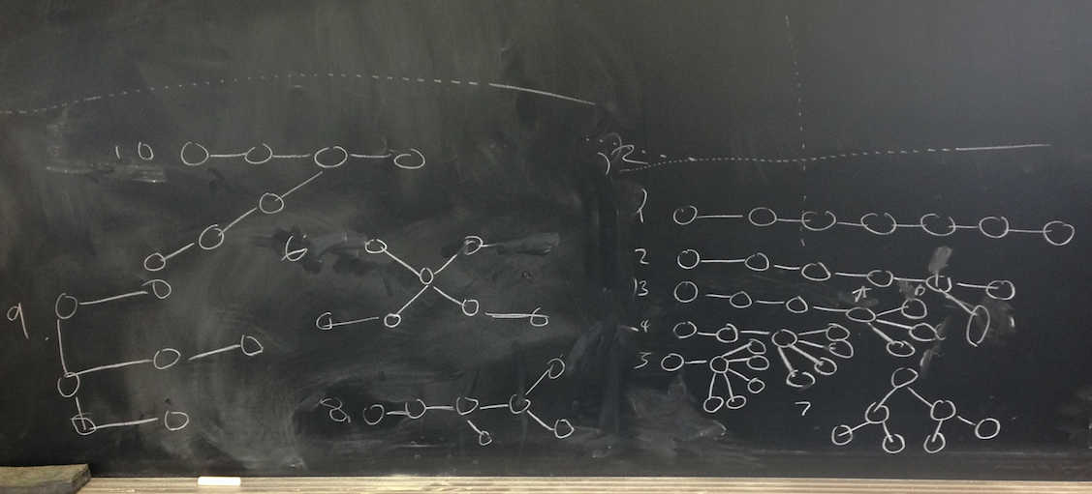

* I found 11 when I made my results, but, 10/11 is pretty good. Also, nice dotted lines in the picture. - Lizzy

3. a. The graph is made up of different trees, forming a bunch of trees. In nature, a group of trees is called a forest.

b. N-K. Assume a graph G that is a tree. By definition, it is both connected and acyclic. If we let v1 be a vertex, and v2 its neighbor, we can continue in this manner until, as we have a finite number of vertices and edges, the graph either connects back to itself or ends with a vertex of degree 1. If the graph connects back to itself, it forms a cycle. If we draw the graph so that it is acyclic, we can show that e, the number of edges, is equal to n-1 with n being the order of the tree.

We have proven that the graph of a tree must be acyclic and have exactly n-1 edges. In order to find the total number of edges in the forest, we would add the values for the number of edges in each tree. When we add all of the values for (n-1), we would get a new value which could be expressed as (n1+n2+n3…+nk)-(1+1+1…+1). This would be equal to N-k(1) with N being the sum of the orders of every tree and k being the number of trees, or components. We multiply 1 by k because we would have to subtract 1 for every tree, and there are k trees.

Fantastic! Your argument in the last paragraph is great; I like how you explained your algebra and your use of notation.--RK

4. A graph that is separated into different components must be disconnected. This means the vertices and edges in the components would be connected, but the components would not be interconnected. If the edges of the graph were added together and equaled less than the number of vertices, then the graph must contain a tree component. This is because trees must be connected and have exactly n-1 edges; in addition to every non tree has at least one cycle (a cycle must have m greater than or equal to n). Since the graph would have less edges than vertices, the graph must be made up of AT LEAST one tree component. ***Q.E.D***

Nice! To make this a bit more precise: each component that is not a tree must have at least as many edges as you have vertices. I think this is what you meant, but the way you argue it is a bit confusing.--RK

5.

|  |  |
| --- | --- |
| Jordan | Melanie |
| Jonathan | Geri |
| Joe | Chisholm |
| Donnie | Victoria |
| Danny | Emma |

* Yes good, those are the answers that I got. - Lizzy

6. 1 2

|  |  |  |
| --- | --- | --- |
| A | C | D |
| B | D | C |
|  |  |  |
| C | B | A |
| D | A | B |

* This chart doesnt make much sense, and isnt labeled, what were you trying to do? - Lizzy

7.

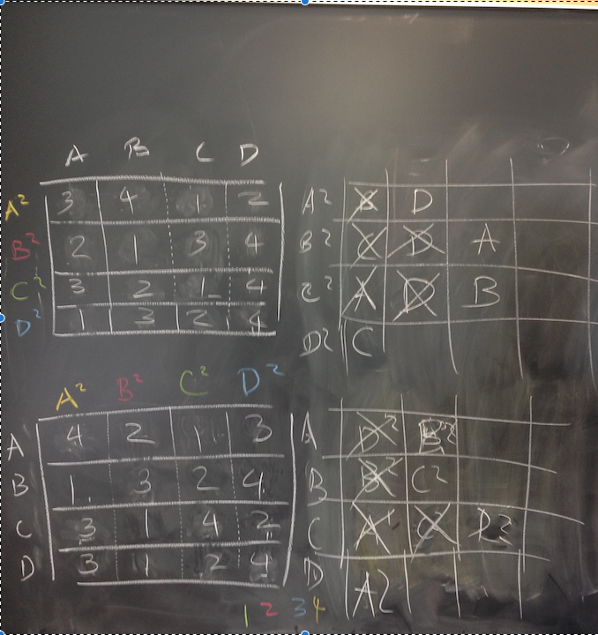

Good job with this problem. It’s a tough one! If you’re submitting a picture as a solution, make sure it’s clear--I can’t read the top row of your bottom-right table. But I remember discussing this with you, and I know your solution was correct.--RK

8. John and Yoko are both each other’s number one choices. Thus, given the choice, they will always choose each other, resulting in them never being paired with anyone else. ***Q.E.D.*** Nice argument. Short and sweet!--RK